**VCS Task**

Establish a new directory, populate it with script files, initiate an empty repository on GitHub, convert the local directory into a Git repository, and link it to GitHub for pushing the code into the repository.Perform merge, rebase, stash commands in following github repo.

* Directories with script files:

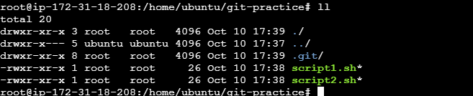

* empty repository on GitHub

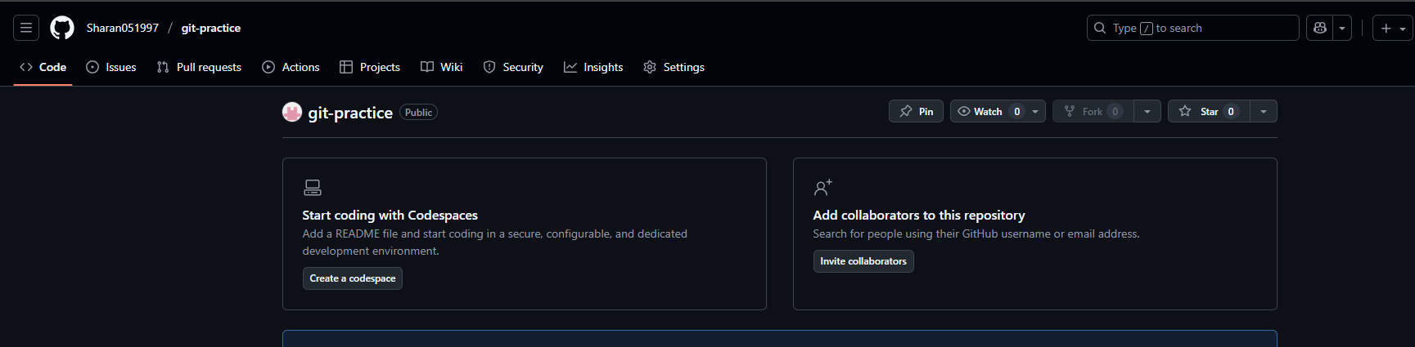

* convert the local directory into a Git repository





* link it to GitHub for pushing the code into the repository

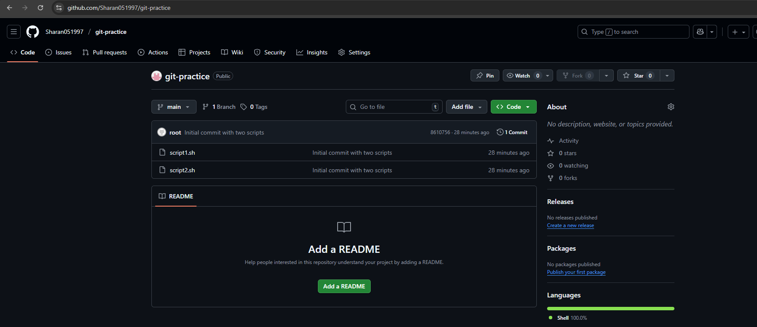

* merge:

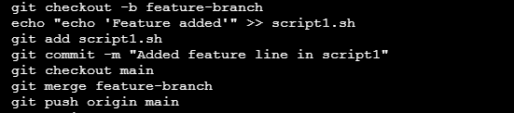

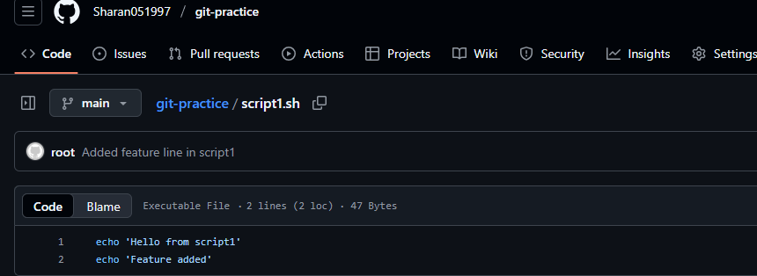

* rebase:

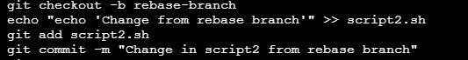



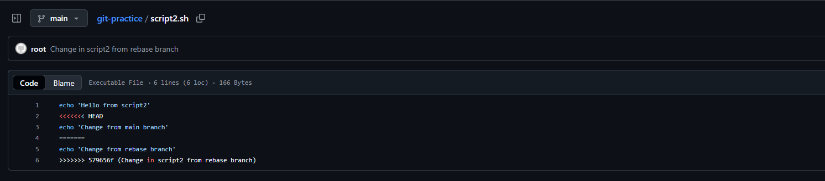

* stash

